A Short Disquisition on Anatopia: Rethinking place and its performance
Sally Mackey
The Royal Central School of Speech and Drama, University of London, London, UK.
The Royal Central School of Speech and Drama, University of London, Eton Avenue, Swiss Cottage, London, NW3 3HY. s.mackey@cssd.ac.uk
Sally Mackey is Professor of Applied Theatre and Performance at Royal Central School of Speech and Drama. Initiating applied theatre at Central, her work has included a Pro-Dean role. She has received several AHRC awards for her research in performing place, has served on research councils and the editorial and advisory boards of two applied theatre journals and is co-editor of the Performing Landscape series.

A Short Disquisition on Anatopia: Rethinking place and its performance

Abstract:
Using examples from three research projects in performing place, 2016-19, and reflecting on previous work, this document reconsiders place and its performance. Anatopia is offered and repositioned as a capacious, malleable, and hopeful term for contemporary places that can be forged within precarious, mobile lives. A case is made, also, for performing place to be more appropriately nuanced as anatopic performance practice and one that takes account of ‘time’ in addition to place. Anatopic performance practice is offered as practice facilitated with residents through subverting and repositioning local environments.

Keywords: performance, place, anatopia, applied theatre

Arising from wrestling with performing place for twenty years, and particularly prompted by recent thinking and practice, I want to reposition the performance of place as ‘anatopic practice’ and, concomitantly, to offer ‘anatopia’ as a term to describe contemporary manifestations of place. This iteration of anatopia helps reconceive and reconcile a temporary locality of place with today’s global context of geopolitical turbulence. Rather than place being assumed as bounded, territorial and homogenous and set in opposition to a fluid and liquid mobility, I am advocating a reconsideration of place as a subjective experience that conjoins these potential binary positions. A constructive and positive repositioning, this is intended to have traction for embracing and enhancing the way we inhabit and think about place today. Naming and claiming the term anatopia here invites further debate as does renaming performing place practices as anatopic practice.
By suggesting my theories of performing place might now be articulated as anatopic performance practices, I am both more precisely describing such work as well as expanding its potential. As I explain below, ‘performing place’ might be perceived as site-specific performance or immersive performance, for example. In renaming the practice, it offers more precision, meaning and intention and, in doing so, aligns performing place firmly with socially-engaged and applied theatres. In addition, such an iteration invites further interrogation by others in this field, encouraging expansion of the practice. Some of the ideas in this article were first presented in a lecture; this piece articulates a further development of that thinking, albeit still conjectural and heuristic. It offers a practice research crucible of conceptual thinking, invoking – and responding to – practical performance projects which, in turn, renames the practices used.
I start with a snapshot of recent projects and this offers an insight into what I have identified and claimed as ‘performing place’: a range of informal and quotidian performance practices by, and with, residents designed to reengage with their locality. This last summarises a complex process of a shift in attitude such that people become more at ease living and operating within their local environment. After invoking ‘topia’, a usurping – if not quite a genesis – of the term anatopia follows. A rare term and one that has capacity for further use, here I amplify anatopia, describing it as a disrupted place, one that is immanently changing and insecure for the subject. Within my usage of anatopia, ‘time’ becomes integral, because I posit anatopia as immanently temporary; I discuss this in the final section. Re-describing place as anatopia sanctions a particular approach to lived experience: a precariousness of place is conjoined positively with a forming of place. In addition to invoking anatopia, and adopting its adjectival form, anatopic, this document repositions performing place as an anatopic practice. My practice of performing place over several years has troubled ideas of place today, provoking this reconsideration of contemporary place as anatopia. In turn, the practices I have previously termed ‘performing place’, I now identify as anatopic performance practices and become focussed on activities that specifically engage with re-envisioning place for residents, both longer-term and temporary.

A snapshot of performing place
My work in performing place developed from and reflects long-term interests in: applied and socially-engaged theatre; forms of quotidian, everyday performance; site-based and ecological practices in urban and rural landscapes; practical research methodologies; and, most specifically, theories and practices of place. A conflation of these interests has prompted practical research projects over the last decade in the north of the UK, Wales, and London. A number of research questions have led various stages of this work. What can practical performance interventions tell us about how abstract concepts such as place, community, dislocation, and belonging, as theorised by thinkers in the field, map onto the 'real life' experiences of vulnerable social groups? What characterises performing place practice and differentiates it from other performance practices? To what extent can models of performing place ease location among community participants? How can such models be shared and disseminated? How does this practice shift our understanding of place in a contemporary, ‘disrupted’ world?

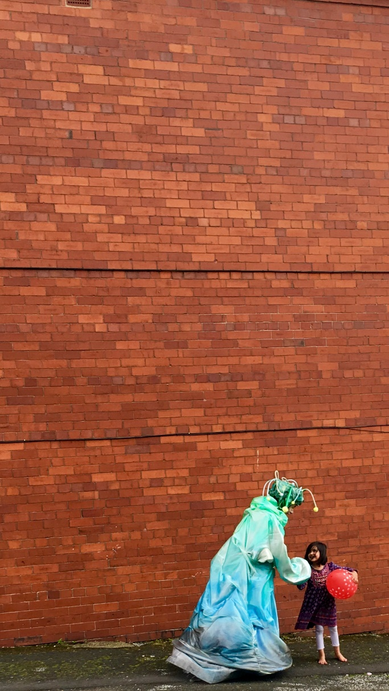

Figure 1: A being from another planet passes back a balloon to a Roma child in Clarksfield, Oldham, 2016. (Photographer: James Atherton)

Increasingly, I have come to assume certain precepts as a result of this extended research: that place remains important in people’s lives; that attachment to place and increased wellbeing can be enhanced by place being ‘performed’ with, for and by residents; that predominantly academic tropes – such as mobility and ‘the liquid’ – need challenging as such terms can feel meaningless for many living in times of change; and that performing place progresses theories of place as well as offering a practical means to re-engage with locality. The last of these precepts has contributed to my current position in forging this essay on anatopia: a desire to reengage with the theorising and ‘naming’ of place and its performance.

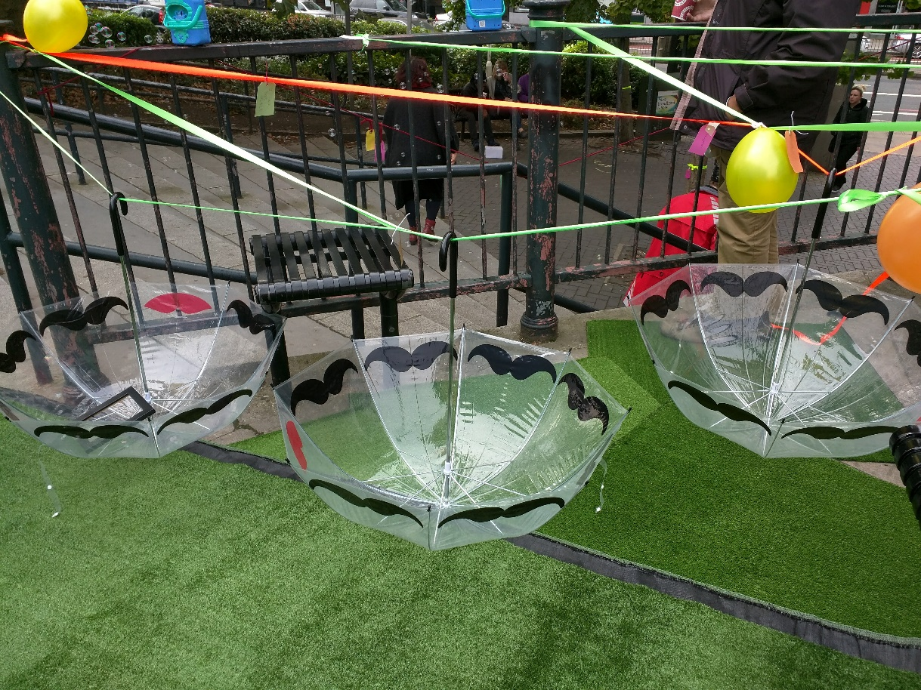

Figure 2: A party site on a triangle of pavement designed by adults in 24/7 care, Camden, London, 2016. (Photographer: Adelina Ong)

In a first project in 2016, I worked in a neighbourhood of Oldham, UK, (Clarksfield) with over a thousand people from the local community, reconsidering this neighbourhood whose character had changed because of new groups of people moving into social housing. Just outside Manchester, Oldham was the UK’s highest producing mill town at the beginning of the twentieth century. In the same year, it was named the most deprived town in England. Predominantly Roma newcomers in 2015 and 2016 were being held in suspicion by existing residents in one of its poorest neighbourhoods, Clarksfield. With Oldham Theatre Workshop as lead facilitators, an overarching narrative was created where beings from another world ‘landed’ in Clarksfield as tourists but also in need of fuel for their space craft hovering above earth; the fuel comprised positive energy that they absorbed through their ‘tentacles’ from the people and place. The narrative enabled the multi-modal community project, Earthed, to coalesce around one story, building interest from, and conjunctions across, all ages and cultures. By presenting ‘strangers’ who inspired affection and assistance, the underlying message was of welcoming new people whilst offering a range of creative school and community workshops, street engagement (the beings walked the streets of Clarksfield interacting with hundreds of residents), and a participatory finale festival culminating in the beings returning to their spacecraft.
In a second project, also in 2016, adults with mental illness in a care facility in Camden, London, were invited to feel more at ease with their locality through a range of performative activities. During 17 workshops, residents at a fully supervised St Mungo’s hostel were invited to share arts activities initially in a garden studio space and, increasingly, beyond the hostel site. Deliberately intended to reframe the local urban landscape and routes, practices offered participants a sense of belonging to that place by interventions such as dressing a pavement area for a ‘party’ and inviting passers-by to participate. Creating less fear of the ‘outside’ and an additional sense of belonging by ‘performing’ the environment differently was, of course, the intention of this work.
Bexleyheath Broadway, a main shopping thoroughfare in south London, is a place of tension that typifies Chantal Mouffe’s agonistic public space. A site of a ‘riot’ between groups of schoolchildren in 2016 and an area not visited by adults when schools were emptying in the afternoons, the Broadway was a contested place. An overarching metanarrative incorporated into over 75 schools and community workshops, a performance for primary schools and nine days of street activities, Performing Places Bexley (2018-19) encouraged residents to perceive the Broadway and Bexleyheath differently. This, the most extensive of the three projects discussed in this article, built upon the successful model piloted in the Clarksfield project, Earthed. A parallel universe, Par Bexia, was experiencing physical and social fragmentation and deracination. Par Bexians came to Bexleyheath to learn how a ‘successful’ community organised itself and cared for its place, taking back those successful messages to Par Bexia.

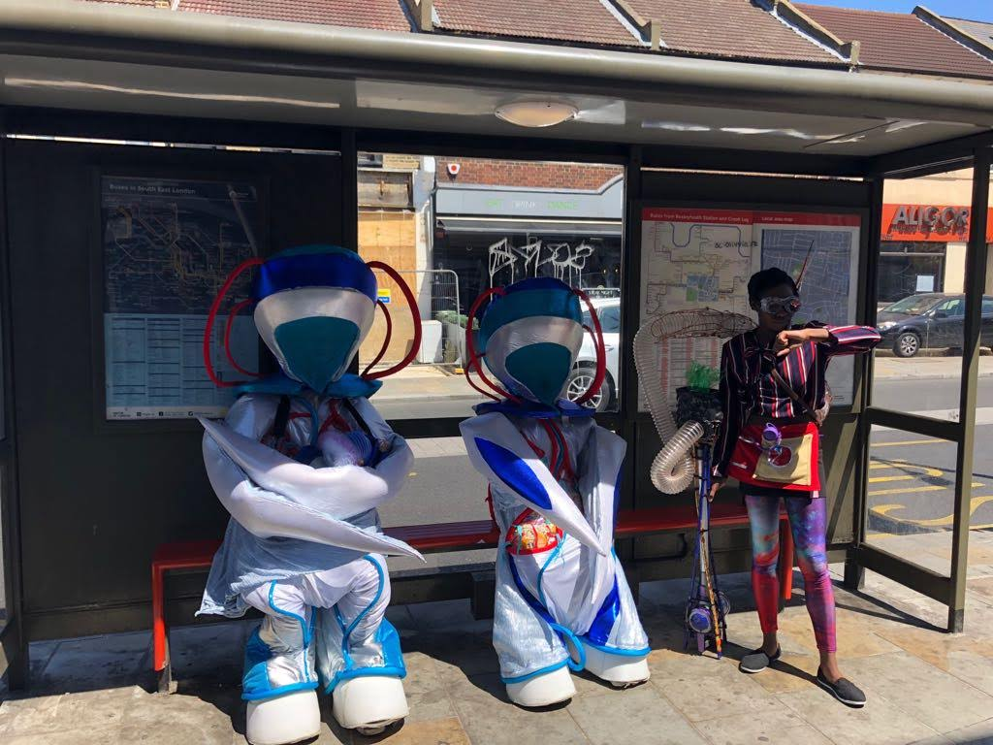
Figure 3: Par Bexian characters and helper musing at a Bexleyheath bus stop, 2018. (Photographer: Steve Hickey.)

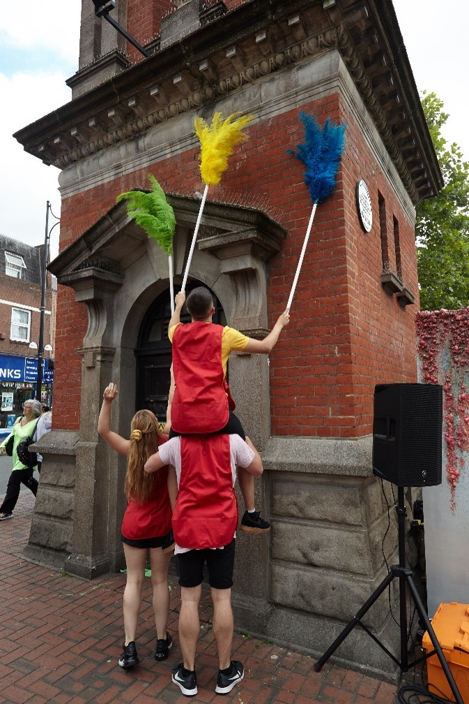

Figure 4: Place-carers cleaning Bexleyheath clocktower, 2019. (Photographer: Steve Hickey)

Each of these projects utilised a broad range of practices that I have increasingly identified as performing place: working with residents in a close exploration of their local territories; subverting the site to ‘re-view’ it – to think of it differently because of curious activities; repeating performances or performative activities such that additional layers of – mainly positive and unusual – memory are forged of that place; regarding others as part of that place through shared activities; challenging the quotidian and everyday operations within that place. Each project has been ‘successful’, if success can be measured through positive external evaluation reports; the projects met their aims. Nonetheless, arising out of this work, three considerations have become increasingly persistent and warrant attention. One is a desire to ‘name’ these practices beyond the perhaps nebulous and sometimes misconstrued ‘performing place’ phrase, to give them an additional and more rigorous identity that also then invites further debate. Second, these practices have surfaced an increasing desire to reconsider and inscribe ‘place’ as inhabited by many project participants today. Third, and within this latter tempering of ‘place’, I have increasingly interrogated time and place, replacing a more usual pairing of space and place. In a new disquisition on performing place practices, I want to posit ‘time’ as integral to anatopic place.

Of Other ‘Topias’ to Anatopia
Topia references a place, often a specific place, in ancient Greek. Not surprisingly, in writing about place and its practices, ‘topia’ terms proliferate. In considering anatopia as having particular resonance for contemporary interpretations of place, I am building on and from previous topias. In my interpretation, anatopia represents a particular form of platial turn and it has the capacity and flexibility to advance performing place as an anatopic practice. Utopia, atopia and the ubiquitous heterotopia, have all been influential in forging my theories of performing place, as I raise below, and thus underscore this ‘bringing forth’ of anatopia. Because such topias have been evidenced, provoked, and challenged in my research projects to date, they represent important conceptual waystations on the ‘journey’ to anatopia and warrant brief attention here to clarify this contribution.
Influenced by Plato’s Republic, Sir Thomas More’s utopia of 1516 was a conjured place of harmonious living. The foundations of his utopian idealism implies a homogeneity of citizens and a uniformity of belief such that all would regard the perfect place similarly. This is a fundamental issue which makes utopia problematic in a non-uniform, globalised world, although the ideal of a perfect society and place remains in the human imaginary. Wryly described by Terry Eagleton as, on the one hand ‘a high-minded, fairly puritanical place’ and on the other, one where ‘its inhabitants are genial, laid-back and agreeably disinclined to do much work’, utopia still retains something of More’s idealism. It is considered an idealistic place of justice and equality in society, and yet is nuanced as being nowhere, a not-place, one that is imagined and unrealistic. It is out of reach. Utopia is familiar in performance writing over the years, carefully disentangled and positioned, and has contributed to my own thinking on the performance of place since beginning this work. Uneasy with its seemingly unachievable intent, however, in the Caer Llan Trilogy (CLT, 2002-2004), I had identified only ‘moments of utopia’ as an aspect of this laboratory experiment in performing place. The CLT comprised four days of intensive experiments in each of three years taking place in and around a field studies centre on the Welsh and English borderland with, on average, 30 participants each year. Beginning with, broadly, site-specific work in Year 1, the work became more nuanced as the years progressed and helped forge my early theories of performing place. Because of the findings from the CLT, I suggested moments of utopia as ‘profound encounters’, not shared as a ‘coterminous homogeneity’ of idealism but, more, ‘occasions where diverse peoples take particular delight [and] pleasure … through experiencing the same performative event within the same material site such that memories of this remain as enduring traces of place’. A final moment in the recent Clarksfield, Oldham, project comprised a low-tech yet highly effective ‘teleportation’ of the mysterious alien beings back to their spacecraft as a culmination of the week’s engagement around the locality. Approximately 400 new and longer-term residents participating and performing together in the afternoon’s festival, with its final moment when the ‘launch pad’ (a withy yurt constructed during the week) was collapsed to show that the beings were no longer inside and had, indeed, been transported back to their hovering spacecraft. This was, I suggest, a moment of shared ‘delight and pleasure’, briefly unifying heterogenous local people. Although the overarching, foundational idealism of utopia has remained awkward for me, moments of utopia remain part of a newly forged understanding of place practices as anatopic.
Similarly, atopia has influenced an invoking of anatopia. Working with those who have been deterritorialised, as has been the case in several performing place projects, feelings of atopia have been all too present because, at its simplest, atopia infers placelessness, without place, a sense of un-belonging, no-place. In various guises, such a lack of place was present in all three projects described above. New Roma residents were outsiders in Clarksfield; the recently arrived adults in Camden care were fearful of nearby unfamiliar streets; older settled residents were ill at ease in Bexleyheath Broadway at certain times of the day feeling displaced when it was inhabited by youth. At a more complex level, and seminally inspired by Roland Barthes (himself prompted by Socrates) atopos can refer to a quality of the ineffable, the unique, strange and unusual, and incomparable: what is under description would not be sullied by the everyday. In his delightful discourse on the lover, for example, Barthes described the loved person as unclassifiable, one who ‘cannot be imprisoned in any stereotype’. All my performing place projects have sought to subvert and make strange the everyday such that they are envisioned differently by residents: ordinary or ‘stereotypical’ perceptions of place have been upset. Most obviously, the introduction of curious beings in the Clarksfield and Bexley projects encouraged locals to see their ‘home’ through new eyes. Decorating a triangle of pavement in Camden with imitation turf, streamers and bubble machine into something unexpected and strange, converted a disregarded passing place into one that was warm and memorable. These different interpretations of atopia – placelessness and the unusual or incomparable – have both been part of performing place practice. With a lack of ‘permanent’ place, atopia, has been implicit in the position of many participants, most obviously. Less explicit is the reference to atopos as antonymic to the predictable and the stereotype; this has become a clear characteristic of my theories of performing place. Both have contributed to this positioning of anatopia.
Something of the different, or alternative – a commonly-understood aspect of heterotopia – has been integral to my early work in performing place and contributes to this iteration of anatopia. In a lecture of 1967, Foucault talked of his theory of heterotopia. Subsequently published after his death (and so not reviewed or edited by Foucault), ‘Of Other Spaces’ is a short, five-page exposition on heterotopia, taken from that lecture. Arguably overused and over-interrogated considering its slight origins, heterotopia (a real, yet alternative or other, place) has been amply cited and pressed into academic service ever since. Drawing from Foucault’s six principles of heterotopia, a heterotopic site is a counter-site that deviates from the ‘norm’ (Foucault suggests rest homes or psychiatric hospitals). It comprises several incompatible and conflicting ‘sites’ of existence and is heterochronous (existing in a particular slice of time). It has to be specifically entered and for a specific function that is apart from any other spatial function; Foucault suggests a ship as the heterotopia par excellence for this. Despite David Wiles suggesting in 2003 that heterotopia was an outdated concept, the term continues to be vaunted, from Doreen Massey stating that all spaces ‘have an element of heterotopia’ to management education in business schools discussed through a heterotopic frame and proposing libraries as heterotopic spaces. Most successfully, in our field recently has been Joanne Tompkins’ convincing positioning for a heterotopic analysis of performance and theatre ‘to better understand the theatrical experience’. In the early stages of this research, I described the Caer Llan Trilogy experiments as invoking heterotopia: the community of participants challenged, inverted and contested the community of place. It has not offered quite the nuance or attunement for my interpretation of place (and its performance) during the last decade of practice, however. In these more recent experiments of research practice, place has not been a counter-site, more a re-envisioned site, for example, and one that aims for an acceptance of plurality of experience rather than conflicted positions. In positioning the performance of place as anatopic, and revisiting the trajectory that has led to this invocation, I can perceive clear elements of heterotopia (e.g. heterochonous events) as I indicate below. Yet, as with these other topias – utopia and atopia – heterotopia has contributed to a puzzling over place rather than offered a comprehensive account of place today.
Anatopia and its associated forms are rarely found in writing, scholarship and everyday speech although they are not neologisms. Most in evidence, anatopism was likely the antecedent term. As James Chandler suggests, Thomas de Quincy believed he invented anatopism in 1850 as meaning ‘geographical blunders’ but, in fact, its first recorded use was by Samuel Taylor Coleridge and refers to something that is out of its place, in the same sense that anachronism references something that is out of time. (An anatopism is often, although not always, an anachronism.) Although infrequently used except as a proper noun (including the name of a squat and a band) anatopia might suggest a state of being out-of-place and very occasional references support this. As part of Scenofest at the Prague Quadrennial, 2007, Kathleen Irwin states in the exhibition abstract ‘[a]natopia defines a state of being in the world in which things (including people) are not in their proper place’. Anatopism has also been defined as ‘a faulty arrangement’, however, which suggests a different description of the term, removing it from its ‘topia’ base. Such a lack of clarity and rare usage invites further consideration of ‘ana’, returning to the Greek to challenge the simplicity of ‘out of place’. When prefacing topia, ana has the capacity to offer a pertinent and relevant ‘special relationship’ to describe contemporary place; it warrants closer attention.
The Greek prefix ‘ana’ has many meanings including up, back, through, under, excess, above, anew, and again. Curiously, ‘out of’ is not given as a definition but all suggest a change of, or movement away from, something or someone. A number of words with the prefix ana contribute meaning: anabolic – a metabolic phase where there is a synthesis from simple to complex substances; anachronism – a change or error in chronology; anagram – a disrupted ordering of letters; anaphase – movement where cells divide. As part of this speculative disquisition, then, I suggest that ‘ana’ can be more comprehensively interpreted as change, difference, or disruption when combined with place.
I am positioning anatopia, therefore, as inferring the subjective experience of a disrupted place, one where people are in-between other places, have experienced, or are anticipating, change or disruption but it is, still, a ‘place’. In this articulation, place may well have characteristics of specific place but one that is not perceived as confined, longstanding, fixed, entrenched, and fortified. It can offer the qualities of attachment, ease, dwelling (however short-term) of enduring places. It is understood, also, as having potential to change, to be disrupted. For the subject experiencing this place, there is every expectation of movement to new places and, indeed, there may well have been change, disruption, and movement from other places. This is not the continuous fluidity for people suggested by a relatively recent academic focus on ‘mobility’, nor the generic non-place famously described by Marc Augé nor Zygmunt Bauman’s ‘ex-territoriality’ where people select to live liquid lives of no fixed abode. Anatopic place is one characterised by disruption and change but where one forges qualities of long-term place, such as a sense of belonging, however temporarily.
Such anatopic place incorporates atopia. To be placeless is part of dwelling temporarily: periods of placelessness combine with temporary phases of location. Moments of utopia, as I have described them above, can indeed be part of making place, of forming place attachment, within places as understood as potentially changing. Immanently, heterotopia challenges and upends quotidian places, which is implicit in anatopic performance practices. These topias contribute to an expanded and re-visioned understanding of anatopia but the traction and value of anatopia is in its privileging temporary place as part of previous or further disruption. This may be – although not necessarily – for people who sometimes have little choice about their deterritorialisations, residing in sites that are not, or have not been, permanent but where each may well become meaningful, however temporarily, as place. Anatopia takes account of other theories of place, and, importantly, ones which celebrate difference and change such as Doreen Massey’s simultaneity of stories-so-far or Ash Amin’s hybrid society of strangers. Famously, Massey advocates place – and space – as a gathering of people who share the stories of their lives to date and Amin promotes pluralism and hybridity as critical for living in contemporary societies. Such aligned emphasis on the temporary implies a particular relationship with time, of course. In such an iteration, anatopia has the magnitude, capacity, and flexibility to advance performing place as an anatopic practice.

Anatopic performance practices
Anatopia embraces and vaunts contemporary place, as it is experienced by many. It formally names and iterates it and, in doing so, sets itself up for further nuancing. Where, then, does this situate anatopic performance practice? How does this conflate with performing place? There are two strands of thought here.
First, I am not suggesting ‘performing anatopia’ which implies any performance of or about disrupted and unstable place, from formal theatre performances to site-based productions. I am, instead, interpreting anatopic performance practices as performative and performance-related activities with people (residents, passers-by) in places that have changed or are changing. Here, anatopic performance practices become a set of activities that explicitly or implicitly challenges aspects of anatopia, particularly any unwanted feelings of placelessness (atopia) or feelings of being out-of-place. Such practices seek to enhance or quicken attachment in new or changed localities, in spite of – or possibly because of – people’s sense of disruption. Anatopic performance practices seek to engage, or reengage, people with their locality. Rather than celebrating a historical continuity of site or performing a reification of permanence which might be mistakenly assumed by the phrase ‘performing place’, anatopic performance practices suggests a forging of attachment to place speedily, and with little attention to historical significance. The performance of place becomes, instead, more clearly about considering place again or anew. Identifying the performance of place as an anatopic performance practice helps iterate that practice. It is undertaken with people who dwell there, however temporarily. Performing Places Bexley aimed to ease the tensions in a contested main street where ‘settled’ and ‘new’ communities struggled to reconcile the changes to place that resulted. In Clarksfield, Oldham, a similar dis-ease was addressed through a performing place project where new Roma residents were unwelcome in a territory of second and third generation white and Asian residents. Camden adults with mental illness found it difficult to settle into their new place; the surrounding streets were perceived as threats. In each project, residents participated in a range of practices designed to shift perceptions of their place by reconsidering the materiality of the site and the concomitant behaviours of those that dwelt there. Young people in Bexley were asked to imagine the pavements’ thoughts (Figure 5) and invited to share the story of the visiting beings (Figure 6); adults in care sprinkled sprinkles on their way to Sprinkles ice cream parlour (Figure 7); a ragged wall was ‘rebuilt’ by disaffected youth in Clarksfield (Figure 10).

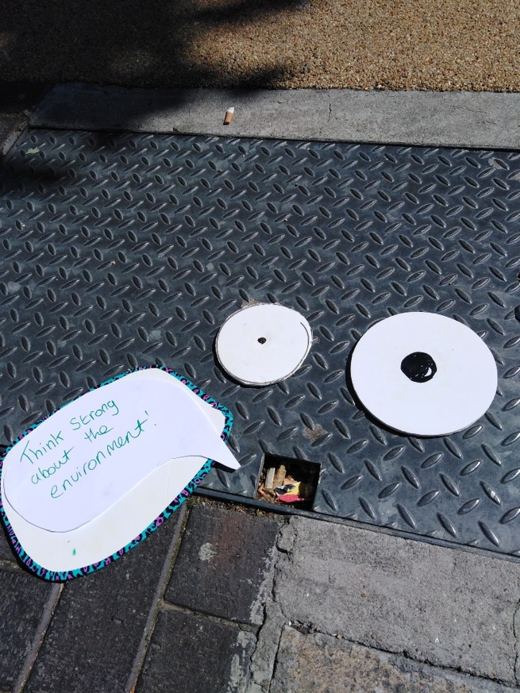  Figure 5 A drain cover speaks, Bexleyheath, 2018 (Photographer Adelina Ong) | Figure 6 Share our story, Bexleyheath, 2019 (Photographer Steve Hickey)  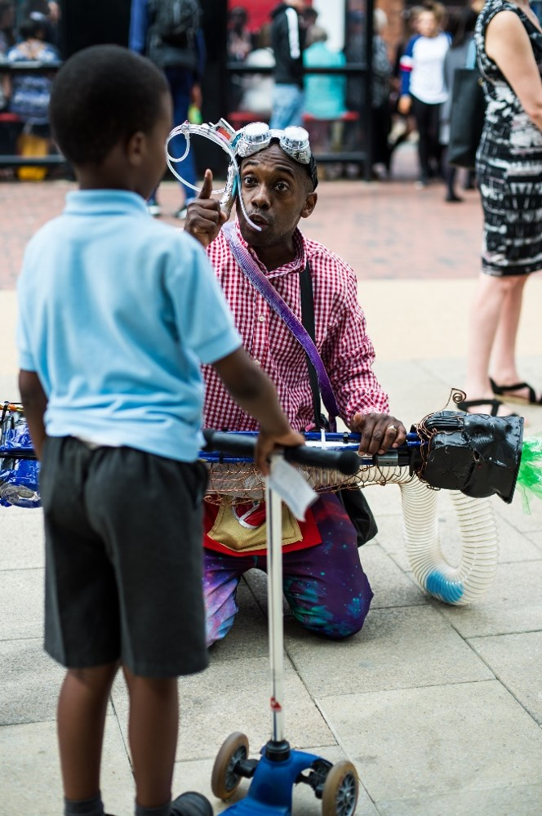

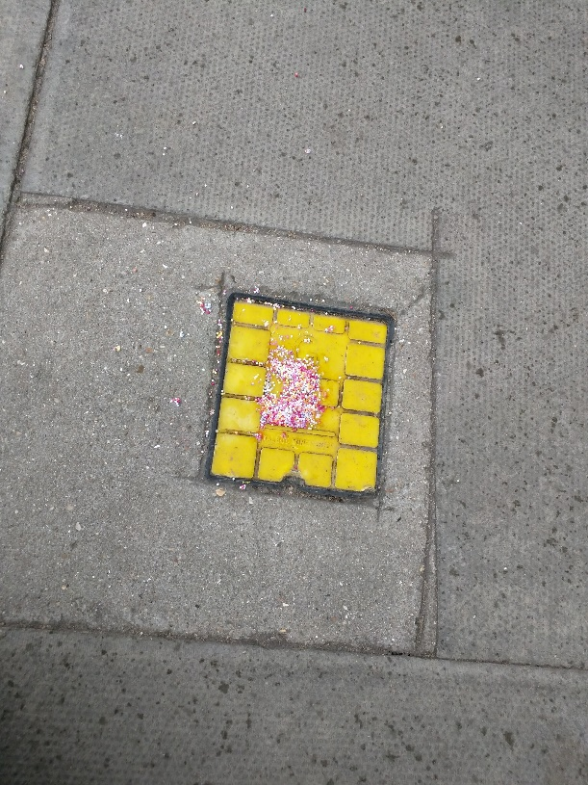 | Figure 7 Sprinkle , Camden, London, 2016 (Photographer Adelina Ong)

Second, anatopic performance practices, as I retrospectively name them, explore place upwards, backwards, through, under, and with excess: they are methodologically aligned with the meanings awarded to the prefix ana. Designed to provoke a reconsideration of the details of place, these forms of performance practice ask participants to reimagine their locality through the following, which I have forged as characterising performing place.

- Re-experiences: repeated ‘low-level’ performance-based activities in everyday settings. A palimpsest of new, and frequently unusual, memories are created. The images in this document represent a range of repeated small performance activities.
- Subversions: improvisations or small events in different locations that subvert or distort the normal use of those locations. Figure 4 offers an example of such subversion: the cleaning of a clock tower with feather dusters.
- ‘Scapes’: framing everyday sites through sound, object, crafts or other methods to create an alternative, even heterotopic, representation of location. A pavement triangle was framed as a party site in Figure 2.
- Markings: activities that focus on very precise detail of places (Figures 9 and 10).
- Narratives: unusual, imaginary narratives and followed throughout a timespan. Clarksfield’s Earthed project and Performing Places Bexley both utilised such narratives; each incorporated unusual beings as new strangers seeking help from local residents.

My research projects have indicated a greater sense of belonging to place, however briefly, through these types of practices that disrupt and provoke a reviewing of place. The animation of thoughts of a drain cover lead residents to reconsider the detail of Bexleyheath Broadway and a new stranger (an alien being) and baby in town are welcomed in a town struggling with other recent newcomers and platial identity. Now on the photographer-participant’s pinboard, an image of a framed peeling wall (Figure 9) is turned into a postcard, marking a new journey, and sprinkling sprinkles on the way to Sprinkles ice cream parlour familiarises the same route for participants. By repeated ‘performances’ in one site (e.g. the repeated street activities in Bexleyheath Broadway) and disrupting the everyday (e.g. the detailed explorations of local routes by the Camden adults in care during 15 workshops), place is perceived anew and changed. These are anatopic performance practices.

  Figure 8 Two babies (Photographer Suha Al-Khayyat) | Figure 9 Wall of fire (Photographer Adelina Ong)  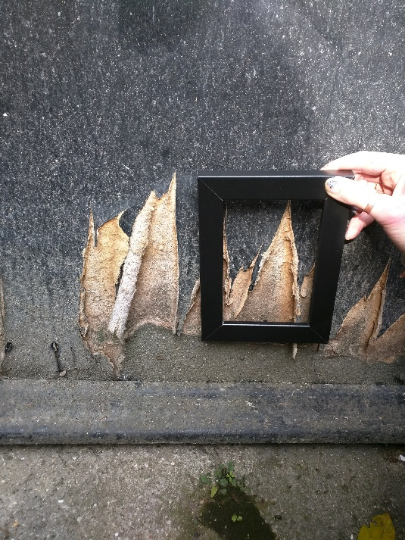

Importantly in my work, anatopic performance practice is within the field of applied theatre. That is, such practice is predominantly undertaken by non-professional participants and often with those who might be perceived as outside dominant narratives. Like much applied theatre work, it takes place in non-traditional performance settings, navigates certain themes or conceits such as community, identity, citizenship, is theoretically rich, grounded in lived experience, and frequently aesthetically joyous. In particular, it is the residents or those who dwell in the place who are the main participants. Anatopic performance practice is usually transient, ephemeral and, for sure, ‘unmarked’ even beyond other forms of theatre. Frequently, it lacks rehearsal and consolidation, for example. Once a moment occurs, it starts to disintegrate and traces diminish immediately. It is captured in rushed photographs and smart-phone film fragments although even this record can be moribund: permission forms for a thousand residents in Clarksfield, Oldham, is not tenable and some adults with mental illness do not wish to be represented on film or video, rendering the work often devoid of the human participants that populated it. Fittingly, perhaps, this performance practice moves on, changes, and alters continuously. Transience has, indeed, become integral to all aspects of this work and has led to an engagement with issues of time and place.

Anatopia and time
To date in my research into place and its performance, I have not engaged with ‘time’ specifically. In rethinking performing place as anatopic performance practice, however, time has become an important part of that thought process. Space has been implicit always: place is imbricated with space, place is spatial, but I have had little to say about time until now. In his 1993 seminal work on place, Edward Casey challenged what he called the ‘gigantomachia’ (contest of giants) between Time and Space which, he suggested, overlooked Place. He advised that we obsess over time, and try to make objective something that was the ‘most “obscure” in human experience’. He advised that we should ‘get back into place so as to get out of (the binding and rebinding of) space and time’. The challenge to time and space continues. Two decades on, human geographer Pete Merriman critiqued Nigel Thrift, Anthony Giddens, David Harvey, Doreen Massey, and others, in an attempt ‘to map out a different way of thinking about the unfolding of events, in which spacing and timing should not be seen a priori to be any more important than other constitutive measures’. Merriman discards time altogether, in fact, and promotes ‘movement-space’ as a key constitutive measure of the world.
Now, however, I am interested in two facets of time that have seeped into my interpretation of anatopia. Time and place have been conceptual bedfellows before in performance, of course; temporal palimpsests of layered sites have been very much part of the development of site-based performance work, for example, with past times and heritage often an influence in such arts practice. I am considering ‘time’ here, however, to expand on a theorising of anatopia and, concomitantly, anatopic performance practice. Anatopia implies subjective disrupted place, I have suggested, and an acceptance that places are precarious and lack stability. Places are in-between other physical places for many: it is expected that they are waystations. Hence, such places are implicitly temporary; they lack permanence and can be measured by time spent. It follows that anatopic practices immanently concern time. Temporality becomes a conceptual bedfellow. I am suggesting that if place is assumed to be disrupted and changed, it is heterochronous. By this, I am suggesting a place is formed for a specific period of time for – and by - the subject. It exists for that person for a particular period and whilst it might be anticipated or remembered outside that period of residing, usually selectively, the subject in that place is bounded by time. There is something of Foucault’s heterotopia here, of course. His alternative sites of spatial disordering are heterochronous; they exist for specific time periods. Anatopic practices, in turn, embrace and engage with such temporality.
In his extensive book, Of Time and Lamentations: Reflections on transience, Raymond Tallis states in salutary fashion, ‘[I]n everyday life we have no problem making sense of time, so long as we don’t try to say what it is. Asking what time is and producing unsatisfactory answers seems a rather pointless activity.’ I make no claims on suggesting ‘what time is’ and am more interested in how time is deployed than explained; this engagement with time is focussed on just two aspects that relate to anatopic place and its performance. It is also speculative and exploratory.
First, the people I work with, the participants in this practice, are on the whole ‘vulnerable’ or at the very least have no or little part in the dominant ordering of temporal narratives, as I mentioned above. I am referencing, here, debates that are part of queer theory and, in particular, I want to borrow something of ‘queer time’, described by Lisa Baraitser as uncoupled from ‘chronoheteronormative time […] being radically outside of the time of normative development’. J/Jack Halberstam suggests that queer time was first identified at the end of the twentieth century, probably because of the compressed time felt by many AIDS victims and their partners. Compressed time, savouring and relishing the present, resulted from an impending sense of diminished time, a lack of future. Halberstam makes the additional point that it is not just the compressed time of potential finitude that suggests queer time, however, adding that queer time is alternative time for those who live outside heterosexual norms and are not, therefore, subject to the same life patterns. Queertime ‘emerge[s] within postmodernism once one leaves the temporal frames of bourgeois reproduction and family, longevity, risk/safety, and inheritance’.
Elizabeth Freeman amplifies this and is particularly useful for the anatopic performance practice I am advocating. She suggests that some human experiences simply do not count towards official timelines. ‘Those forced to wait or startled by violence, whose activities do not show up on the official time line, whose own time lines do not synchronize with it, are variously and often simultaneously black, female, queer’. I would add to that list many of the vulnerable groups I have been working with. Refugees fleeing countries, those with learning and physical disabilities, adults with mental illness and elders with dementia, for example, do not notably contribute to, or participate in, dominant bourgeois temporal narratives. The temporal fluidity that Freeman is advocating, in opposition to ‘official’ time lines, applies to many of the participants in the performing place projects. They have different dealings with time; they do not participate in the chrononormative. Stephen Farrier has suggested that ‘[t]ime has a deep relationship to a politics of identity and an inability or unwillingness to attend to its normalities can produce material social castigation to those who do not/cannot live within this reproductive time’. Critically, for those I have been working with, disruption hasn’t necessarily been chosen; rather, it has been thrust upon them. Time has a porosity and a fluidity for many participants in the performing places projects. In those projects identified in this article, this was most noticeable working with adults with mental illness in Camden who were unable to attend to the normalities of time and for whom there was most certainly an inability to conform to official time lines. Pragmatically, these adults struggled to even attend the fixed time of the performing place workshops. My point here is that in researching the performance of place in recent years, I have become aware of the ‘material social castigation’ – as Farrier phrases it – of some participants because they do not, and often cannot, live lives of chrononormative time. For many in these projects, place is experienced and performed through temporal disruptions, therefore, in addition to platial disruptions.
A consideration of time is integral to a theory of anatopia, as a way of conceiving and understanding the current platial turn. A distancing from dominant temporal narratives often accompanies a disruption to place, particularly for the vulnerable. Such groups do not necessarily dwell within chrononormativite time. This, then, becomes an important part of thinking about anatopic place.
I return briefly to an aspect of time that interested me over a decade ago: the expansion of a moment in time during place practices such that time ‘thickens’ and, as a result, place thickens. I’m suggesting that a density of place practices challenges normative time which, in turn ‘thickens’ places and thus speeds up attachment to places. First observed during the laboratory of performing place practices of 2002-04, the Caer Llan Trilogy on the borderlands of Wales and England, I recognised that time began to hold a different quality. Because of a density of activities throughout each day and simultaneously, it led to a slippage in temporality. As others did, I found myself saying, for example: ‘We talked about that yesterday or the day before’ to then realise that the discussion had been earlier the same day. Time did not pass as it more usually did.
Seemingly, we were living in a peculiar kind of extended present; several activities happened in quick succession, as well as simultaneously. (Several groups worked at the same time and could be heard and seen around the site.) This intensified – or made dense – each moment. Milan Kundera phrases, rather beautifully, what takes place in an ordinary moment: ‘In the course of a single second, our senses of sight, of hearing, of smell, register (knowingly or not) a swarm of events, and a parade of sensations and ideas passes through our heads’. I am suggesting that a focused engagement of performing place activities multiplied or amplified each moment or ‘single second’. The density of practices in our Welsh performing place experiment shifted our experience of time; we were not operating within a normative sense of time. An expansion or thickening of time in turn thickened place; place became more thoroughly inscribed because of that thickening and that unusually extensive ‘swarm of events’. In Enduring Time, Baraitser describes various forms of ‘elongated’ time: of delay, of beginning again, of incremental change. She begins her book with a reference to Denise Riley’s experience of time when her son dies and a suspension of time ensued. The time I describe is both a form of suspension as well as an elongation. Baraister’s rich and captivating treatise on time and the politics of care is complex and, as the title suggests, her book focuses on enduring. I am suggesting a more pleasurable experience, however: an elongation of time because of a density of creative and enjoyable experiences. For me, anatopic performance practice comprising a multitude of repeated performative activities is a way of accelerating attachment to place such that dwelling in place is eased and enhanced, whilst still recognising its temporary quality. Holding back normative time in the context of anatopic performance practices would be a positive experience.
Anatopic performance practices comprise a folding of time, a temporal palimpsest, ‘thick’ time. This is achieved through multiple activities such that time is elongated as place is explored up, under, backwards, and through. Whilst not fully suspended, a concentration and proliferation of activities within a given period encourages an amplified opportunity for being in place: it is experienced densely and place inscribes and binds itself to the person more rigorously. Importantly, too, the focus in such practice is the present or the immediate; this removes any reference to the history of a place or heritage which is perhaps a more usual expectation in performances of site. ‘Present time’ further characterises anatopic performance practices.

In conclusion, I propose anatopia to be brought forth – to be further theorised – as amply and constructively describing place for many in the contemporary age. In this iteration, anatopia describes a precarity of place yet allows for the forging of place within such changed and disrupted lives. It is temporal; it immanently sanctions place for those living outside normative time flows. Anatopic performance practices invite local participants to re-engage with place using plentiful, unusual and ‘under the radar’ performance-related activities that seek to subvert yet amplify the details of place. Such anatopic explorations quicken new attachments to place, easing belonging.

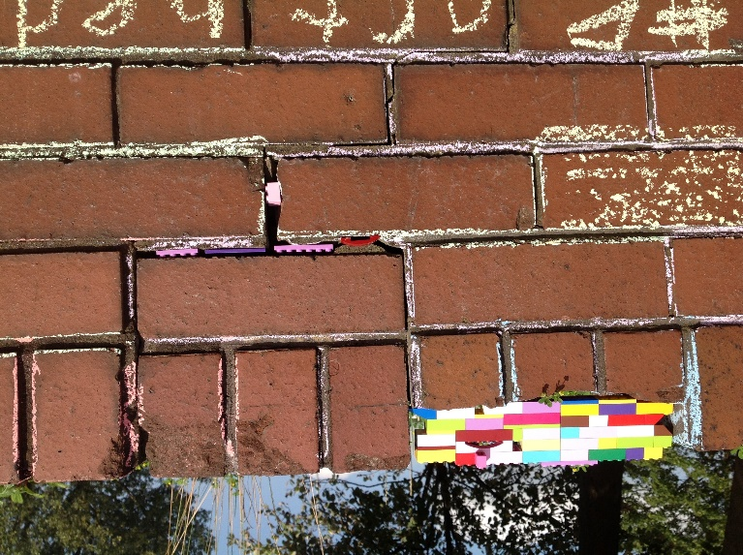 | Figure 10 Gaps mended by Clarksfield youths, 2016. (Photographer Becky Proudfoot)

On being awarded the David Bradby International Research prize, this was a keynote delivered at the TaPRA (Theatre and Performance Research Association) conference at the University of Salford in September 2017.
Sally Mackey, ‘Drama, Landscape and Memory: “To Be is to Be in Place”’, Research in Drama Education 7.1 (2002): 9-25; Sally Mackey, ‘Performance, place and allotments: Feast or Famine?’ CTR 17.2 (2007): 181-191; Sally Mackey, ‘Performing Location: Place and Applied Theatre’, in Critical Perspectives on Applied Theatre , ed. Jenny Hughes and Helen Nicholson (Cambridge: Cambridge University Press, 2016), 106-126.
See https://www.bbc.co.uk/news/uk-england-35842488 (accessed March 26, 2020)
For an evaluation of the success of this project, see http://www.performingplaces.org/docs/evaloldham.pdf
See http://www.performingplaces.org/local.html for further details of the Oldham and Camden projects.
Chantal Mouffe, ‘Arts and Democracy: Art as an Antagonistic intervention in Public Space’ http://digitalcraft.wdka.nl/images/8/86/Art_and_Democracy_-_Chantal_Mouffe.pdf (accessed August 20, 2017)
See https://www.cssd.ac.uk/performing-places-bexley for further details of Performing Places Bexley.
Mackey, ‘Performing Location’ 106-126. Sally Mackey, http://www.performingplaces.org/docs/ppbrochure.pdf (2017)
See, for example, http://www.performingplaces.org/docs/evalcamden.pdf and http://www.performingplaces.org/docs/evaloldham.pdf
Terry Eagleton, ‘Utopias, past and present: why Thomas More remains astonishingly radical’ The Guardian online October 16th October, 2015. (accessed February 1, 2020.) https://www.theguardian.com/books/2015/oct/16/utopias-past-present-thomas-more-terry-eagleton
See, for example: Selina Busby, ‘Finding a Concrete Utopia in the Dystopia of a “sub-city”’, Research in Drama Education: The Journal of Applied Theatre and Performance 22.1. (2017): 92-103. Jill Dolan, Utopia in Performance: Finding Hope at the Theatre (Michigan: University of Michigan Press, 2005).
Sally Mackey, ‘Towards an Understanding of the Performance of Place’ (PhD thesis, University of Warwick 2008): 173-178.
These participants trained previously at Central as applied theatre and drama education practitioners.
See www.performingplace.org
Mackey, ‘Towards a Performance of Place’, 177.
Roland Barthes, A Lover’s Discourse: Fragments, trans. Richard Howard (New York: Hill and Wang, 1978), 35.
Michel Foucault ‘Of Other Spaces', Diacritics Spring (1996 [1967]): 22-27.
Foucault, ‘Of Other Spaces’ 25-27.
David Wiles, A Short History of Performance Space (Cambridge: Cambridge University Press, 2003), 8.
Doreen Massey, For Space (London: Sage 2005), 116.
Timon Beyes and Christoph Michels, ‘The production of educational space: Heterotopia and the business university’ Management Learning 42.5 (2011): 521-536
Gary P. Radford, Marie L. Radford and Jessica Lingel, ‘The library as heterotopia: Michel Foucault and the experience of library space’, Journal of Documentation 71.6 (2015): 1265-1288.
Joanne Tompkins, Theatre’s Heterotopias: Performance and the Cultural Politics of Space (London and New York: Palgrave Macmillan, 2014): 16.
See http://www.performingplace.org/Pages/Docs/About_Community.pdf
James Chandler, England in 1819: The Politics of Literary Culture and the Case of the Romantic Historicism (Chicago and London: University of Chicago Press, 1998).
Samuel Coleridge, The Literary Remains of Samuel Taylor Coleridge: The Fall of Robespierre. Poems. A Course of Lectures. Omniana (London: William Pickering, 1836): 317.
Kathleen Irwin, ‘Home and Away: Utopia / Dystopia and Anatopia’, 2007 http://www.scenofest.org/exhibition/Birds/BDA_CA04%20KathleenIrwin/BDA_CA04.htm (accessed February 27, 2020)
See https://www.definitions.net/definition/ANATOPISM
Fillippo Trentin similarly wrangles with ana in a rare reference to the prefix. Identifying upwards, backwards (disrupting a sequence) and through as the most prominent definitions of ana, he gives ‘anatopy’ an emphasis on variance, difference and a lack of contiguity supporting my interpretation of anatopic as unstable and disrupted. Fillippo Trentin, ‘Warburg’s Ghost: On Literary Atlases and the “Anatopic” Shift of a Cartographic Object’ in De/Constituting Wholes: Towards partiality without parts, ed. Manuele Gragnolati and Christoph F.E. Holzhey, (Verlag Turia + Kant: Berlin, 2012): 111.
Tim Cresswell, On the Move: Mobility in the Modern Western World (New York and London: Routledge, 2006). Tim Cresswell, ‘Towards a Politics of Mobility’, in Routes, Roads and Landscapes, ed. Mari Hvattum, Brita Brenna, Beate Elvebakk and Janike Kampevold Larsen (Abingdon and New York: Routledge, 2016), 163-177. Peter Adey and Rachael Squire, ‘Mobilities’ in Routledge Handbook of International Political Sociology ed. Xavier Guillaume and Pinar Bilgi (New York and London: Routledge, 2017), 204-213.
Marc Augé, Non-Places: an Introduction to an Anthropology of Supermodernity, trans. John Howe (London: Verso, 1995).
Zigmunt Bauman, Liquid Times: Living in an Age of Uncertainty (Cambridge: Polity Press, 2007).
Massey, For Space 130.
Ash Amin, Land of Strangers (Cambridge: Polity Press, 2012).
In referencing the seminal text by Peggy Phelan, I allude to the lack of visibility or presence in dominant narratives of those participating, in addition to the lack of permanence of the performance moments. Peggy Phelan, Unmarked: The Politics of Performance (London and New York: Routledge, 1993).
Edward Casey, Getting Back into Place: Towards a Renewed Understanding of the Place-World (Bloomington: Indiana University Press, 1993): 10.
Casey, Getting Back into Place, 11.
Pete Merriman, ‘Human Geography without time-space’, Transactions of the Institute of British Geographers 37.1 (2012): 13.
See, for example, analysis of performances in heritage sites throughout Tony Jackson and Jenny Kid (eds), Performing Heritage: Research, Practice and Innovation in Museum Theatre and Live Interpretation (Manchester: Manchester University Press, 2012).
Raymond Tallis, Of Time and Lamentations: Reflections on Transience (Newcastle: Agenda Publishing, 2017): 430.
Lisa Baraister, Enduring Time (London: Bloomsbury Academic, 2017): 92.
J/Jack Halberstam, In a Queer Time and Place: Transgender bodies, subcultural lives (Sexual Cultures) (New York and London: New York University Press, 2005): 5
Halberstam, In a Queer Time, 7.
Elizabeth Freeman, ‘Time Binds, or Erotohistoriography’ Social Text 23.3-4 (84-85) (2005): 57.
Stephen Farrier, ‘Sticky stories: Joe Orton, queer history, queer dramaturgy’, Studies in Theatre and Performance 37:2 (2017): 185.
Sally Mackey, ‘Transient Roots: performance, place and exterritorials’, Performance Research: On the Road, 12.2 (2007): 75-78.
Milan Kundera, The Art of the Novel, trans. Linda Asher (London: Faber and Faber, 1998): 70.
Baraister, Enduring Time, 95, 96, 50.
Baraister, Enduring Time, 1.

